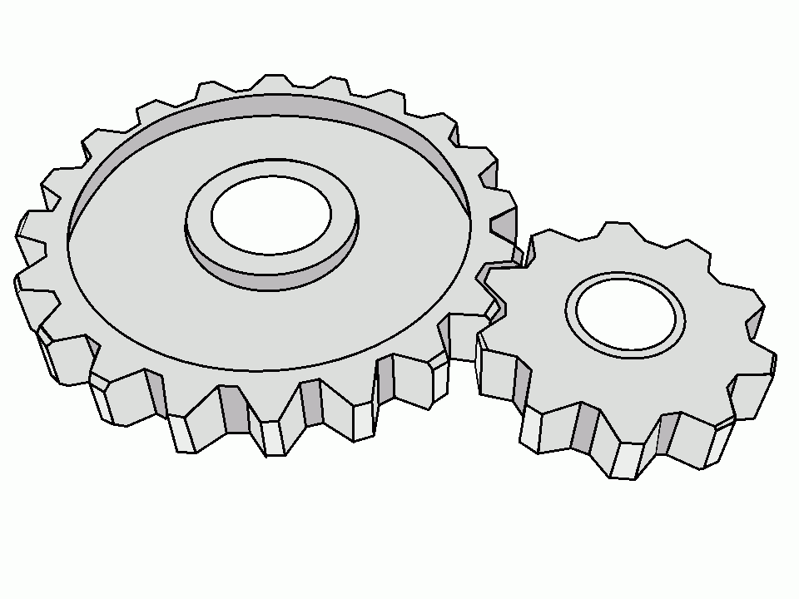
POE Study Guide

Unit 1
Lesson 1.1 – Simple Machines
- 6 different Simple Machines (1.1.1)
- IMA & AMA (1.1.2)
- Gears, Pulley drives and Sprockets (1.1.5)
- Compound Machines (1.1.6)
Lesson 1.2 – Energy Sources
- Renewable, Non-renewable and inexhaustible (1.2.1)
  - Examples of each type
- Series and Parallel circuits (1.2.3)
- Applying Ohm’s Law for circuit calculations (1.2.4)
Lesson 1.3 – Energy Applications
- Thermodynamics (1.3.3)

Unit 2
Lesson 2.1 – Statics
- Centroids (2.1.1)
- Moment of Inertia/Beam Deflection (2.1.2)
- Free Body Diagrams (2.1.3)
- Force Vectors (2.1.4)
- Truss Calculations (2.1.7)

